Business Economics
Project Work 2
How does the length of the hemline and types of cosmetic advertisements correlate to macroeconomic fluctuations in Hungary from 1950 to 1992?
Eszter Anna Kiss

Budapest, 28. 11. 2025

Declarations
- I, the author, hereby declare that this Project Work/Thesis is the result of my own original and independent work. During the writing process, I followed the rules of referencing, and I used quotation marks to signal verbatim quotations. I indicated the extracts I used from my own previous work. I understand that plagiarism leads to disciplinary action.
- I, the author, hereby declare that the data in the Project Work/Thesis are used lawfully. I understand that the document (the Project Work/Thesis) cannot be made confidential.
- Furthermore, I declare that:
- I have actively informed myself about the potentials and limitations of artificial intelligence software to be able to use them responsibly.
- the content acquired from artificial intelligence is listed in the table below.
- I have checked that the data used, generated by artificial intelligence, are correct and valid.
- I am aware that, as the author of this document, I am responsible for the information and statements included in it.
- I am aware that violating the rules regulating the documentation and ethical use of artificial intelligence is considered plagiarism and results in the consequences declared in ELTE’s Academic Regulations for Students (Eötvös Loránd University Organisational and Operational Regulations – Volume 2, in Hungarian: ELTE Hallgatói Követelményrendszer, or ELTE HKR, for short).
Budapest, 28. 11. 2025

Abstract
This thesis examines the empirical validity of two unconventional economic indicators, the Hemline Index and the Lipstick Index, through the analysis of women’s fashion magazines between the 1950s and the 1990s. The research compares American Vogue with Hungarian magazines such as Ez a Divat and Dolgozó Nő in order to analyse how different political and economic systems influence fashion trends, luxury consumption and advertising behaviour. The study combines quantitative and qualitative analysis by measuring skirt lengths, tracking luxury advertisements and observing structural changes in magazine content across different economic periods. The findings show that the Hemline Index produced inconsistent results, especially in Hungary, where political transition, Western cultural influence and the spread of fast fashion frequently overpowered domestic economic conditions. In contrast, the Lipstick Index showed a more stable relationship with macroeconomic fluctuations in both countries. The research also revealed strong seasonal advertising patterns within the fashion industry, particularly the increased dominance of affordable luxury products during financially constrained periods. Overall, the thesis concludes that the Lipstick Index reflects economic fluctuations more consistently than the Hemline Index.

Table of Contents
1. Introduction 6
1.1. Research background and context 6
1.2. Research problem and objectives, the significance of the study 7
2. Theoretical and Conceptual Background 9
2.1. The Hemline Index: Theoretical framework and background analysis 9
2.2. The Lipstick Index: Theoretical framework and background analysis 12
3. Methodology 15
3.1. Research design and approach 15
3.2. Data consideration 16
3.3. Data sources and sample selection: Magazine type selection 16
3.4. Data collection methods 17
3.5. Data analysis plan 18
3.6. Prototype 19
4. Results and Findings 23
4.1. Establishing the baseline 23
4.2. Index interpretations 24
4.3. Single country analysis 26
4.4. Cross approach analysis 27
4.5. Cross country analysis 29
5. Conclusion 33
Appendix 35
Reference list 39

Introduction
Macroeconomy shapes even the smallest aspects of our everyday life, influencing customer behaviour, aesthetic choices, cultural values and the evolution of trends. Economic cycle such as a recession or inflation can shift how individuals perceive value, make purchasing decisions and respond to visual or cultural cues, including colour palettes, design choices and stylistic tendencies. Shifts in economic stability can change individual and collective perspectives as well, often redefining what is considered desirable, aspirational or give comfort.
The scale of the fashion industry is much dominant than normally we would think. As said by Akram et al., (2022), “The fashion industry is one most significant manufacturing industries that generate an economy of 3 trillion dollars and contributes to 2% of world gross domestic product (GDP). It positions the industry as one of the most influential manufacturing sectors in the world. Its continuous cycle of production makes it a critical driver of production, trade and value creation.”
“From the perspective of fashion, clothing is our first social interface. Clothing functions as an important and necessary social tool that interfaces our bodies with society. Through clothing we inform others of our personal and collective affinities. Clothing can signal many aspects of a person’s social identity including socio-economic status, gender, religion, and occupation. Doctors, nurses, soldiers, police and military men, postmen, judges, priests (...) are all identified and called upon by their attire.” (Kodžoman, 2019)

Research background and context
As van Baardwijk and Hans Franses stated, “Urban legend has it that the hemline is correlated with the economy.” “In times of decline, the hemline moves towards the floor (decreases), and when the economy is booming, skirts get shorter and the hemline increases. This theory was developed by George Taylor in 1926 after noticing that, as the country enters recession, women rather substitute towards wearing longer dresses.” (Kim & Kim, 2013)
In a recession not just fashion changes, not just skirts lengths get longer, it’s customers purchasing power which start to decline as real incomes fall, and goods become more expensive. This is where we can introduce the lipstick theory as well. “It is well known that when the economy is bad, people tend to cut down on their spending and put off necessary purchases. While many sectors have seen declining revenues during recessions, the cosmetics sector has recently been identified as a sector that is doing relatively well.” (Alozian & Shatila, 2023) “Which is a theory proposed by the chairman of L’Oréal after experiencing multiple increases in sales during recessions. People who are tight on money want to buy something nice for themselves, so they may temporarily forget about their financial difficulties.” (Alozian & Shatila, 2023).
This thesis will be primary focused on women’s fashion and examine how female income earners are influenced by the changes in macroeconomic conditions. The study aims to observe how the skirt lengths and the size of luxury purchases changes as the economy fluctuates. For a better comprehensive analysis, this study research cross national, dual method approach. In which it will examine both the top down influence of luxury publications and bottom up consumer approach found in the lifestyle magazines.

Research problem and objectives, the significance of the study
The Hemline and Lipstick Index, with many of other non-traditional indexes, are not examined with the same methodological rigor applied in conventional macroeconomic indicators. They often referred as an urban legend or a theory, which hold under certain conditions but can fail in some contexts. Therefore, their relevance is less valuable than a GDP or Inflation Index in analysing actual changes in the economy. Existing publications often wrong about testing these indexes, researchers forget to analyse proper country specific magazines making them rely on improper datasets or fail to analyse the broader historical and cultural environment. Additional limitations arise from the lack of visual dataset, because not many magazines are inaccessible due to copyright issues. Researchers can come to false conclusion because they forget to account for the differences between the preferences, consumption and purchasing power of high society and the general population.
In this thesis, I will analyse both lifestyle and fashion magazines during historical downturns and expansions within a historical setting focusing on two countries: Hungary and America. My hypothesis is that, during economic hardships, the fashion trends will shift towards more traditional styles, showing us a lower hemline, with a high amount of lipstick related advertisements. On the contrary, during economic wellbeing, I expect to see more modern fashion choices, indicating a higher hemline with fewer lipstick advertisement, potentially more high value luxury advertisement.
For this analysis, the selected Hungarian fashion magazine is Ez a Divat and for lifestyle magazine is Nő, also previously called Dolgozó Nők. While for America the source to compare our dataset will be the American Vogue.
This thesis will apply both quantitative but a qualitative analysis to examine the Hemline and the Lipstick economic theory. The objective is to interpret how economic fluctuations is reflected on fashion choices, advertising patterns, and broader customer culture.

Theoretical and Conceptual Background
This research can be compelling because it extends beyond traditional economic analyzation and incorporates a more psychological, sociological perspectives concerning the women’s consumer behaviour. It’s especially relevant because there is only limited amount of academic attention given to these unconventional economic indicators. However, they can have potential to reveal how financial constraints and economic fluctuations shape everyday decision-making. Understanding the situation of how individuals are influenced by the amount of financial resources they have, can offer valuable insights into the economy, behaviour and culture.
Doing a broader examination of other unconventional economic indicators can make us understand how our seemingly minor behaviour reflects how the economy fluctuates. To contextualize non-traditional metrics, economists frequently reference indicators like the Big Mac Index to evaluate currency purchasing power parity, or the Skyscraper Index, which links the construction of record-breaking buildings to the peaks of business cycles right before a recession. While useful, these indicators focus on corporate pricing and real estate speculation, whereas the Hemline and Lipstick indexes capture intimate shifts in consumer psychology.

The Hemline Index: Theoretical framework and background analysis
One the widely discussed unconventional economic indicator is the Hemline Index. It was proposed by George Taylor in 1926, and his theory suggested correlation between women’s skirt length and the macroeconomic performance. “According to the theory, which is still followed by many stock brokers today, when the economy is flourishing, skirts get shorter, and when the economy is performing badly, skirts get longer.” (Kim & Kim, 2013)
The economy expands when the following characteristics holds: long lasting, steady 2-5% inflation rate, and increasing stock performance, during this period people will have a better financial security and have an increased disposable income. When the economy is steady, people are more likely to invest, spend money on extra goods and participate in cultural trends. For women this may appear as buying smaller skirts and buying hosiery to cover their legs. Since hosiery is fragile and is easy to tear, it needs requires frequent replacement. A continuous demand can signal a consistent spending. Moreover, shorter skirts are a symbol of the modern norms and the social-party culture. This lifestyle shows that an individual, especially women, feel financially stable enough to engage in afternoon activities without a concern of the budget.
During recessions or deflationary periods, households face budget constraints as incomes lag behind expenses, forcing a shift toward reduced spending and prioritized savings. This constraint shifts consumer trends toward practical, durable apparel and reduces hosiery consumption due to replacement costs. Consequently, economic contractions steer fashion toward conservative, traditional values, historically exemplified by the rise of the longer, more modest "Gibson Girl" silhouette. “Considered the “New Woman” in comparison to her Victorian predecessors, she was portrayed “as tall, long-legged and graceful, with upswept hair, faintly pink cheeks, a provocative eye, and a cool detached air. Her face was flawlessly beautiful, and her figure was slim yet voluptuous. Physical attributes aside, the Gibson Girl also proved to be progressive; she was “an independent and often well-educated young woman poised to enjoy a more visible and active role in the public arena than women of preceding generations.” (Simon & Mamp, 2021)
Psychological mentality of women changes during these hardships too. During the interwar period, early marriages became popular, because individuals found emotional and financial stability with a partner than alone. Fashion, as well as dating norms became more conservative and modest because in times of economic uncertainty, people look for believes that provides predictability, like religion. This influence often came with more conservative and traditional trends, like longer dresses
The first report was published in 2010 by Marjolein van Baardwijk and Philip Hans Franses, with the title of: The hemline and the economy: is there any match? In this report they constructed their own dataset based on quantifying qualitative fashion magazine pictures and evaluated the results against the NBER chronology of the economy cycle. Their work gave the idea to categorise the skirt lengths and to turn the set of magazine analysis into numerical variables. “There are 5 distinct dress lengths. We distinguish Mini (1), Ballerina length (above the knee cocktail) (2), below the knee (3), Full length (ankle) (4) and Floor length (5).” (van Baardwijk & Franses, 2010.) Although, I find that they try to generalize their results while comparing a French fashion magazine L’Officiel, to the U.S NBER chronology. This approach forgets to account for the differences between counties and that they have differences in economic experiences. Especially, the 2008 Global Crisis, where the economic shock was substantially stronger in the United States than in France. Therefore, a French GDP based analysis would have made a better reference if they would analyse the fluctuations there.
Legka (2013) proposed using sewing magazines to better reflect bottom-up consumer sentiment. Also, she briefly connects the Lipstick Index to the Hemline Index when discussing the overall patterns of the women consumption behaviour in respect to economy fluctuations. The Lipstick Index can correlate with the hemline and economy and explain negative relationship between them. “Obtained results based on monthly data for United States reveal a positive correlation between unemployment and spending on beauty products, such as cosmetics, clothing and accessories.” (Legka, 2013.) Legka’s (2013) empirical framework also have inconsistencies; when she reused the previous findings from the French fashion magazine, L’Officiel, and compares the results to the German sewing pattern. Combining two different types of magazines can give distorted results and can make results incorrect, so making our conclusion weak.
Additional methodological insight comes from the thesis by Gabrielly Humes (2021): Testing the relationship between fashion trends and the stock market also called for many improvements in the understanding of the migration of trends between social classes. “As for the flow of fashion trends through society, three theories are most commonly assumed: the trickle-up theory, trickle-down theory, and trickle-across theory. The trickle-up theory states that fashion trends start as street wear and travel up until the trend is considered high fashion. The concept of the trickle-down theory is that trends start on the runways as high fashion, move through the classes, and trickle down until the trend is considered street wear. The trickle-across theory assumes that trends move 3 horizontally across groups of similar status with little lag time between them.” (Humes, 2021.) The writer also uses the Vogue as the primary data source as a high fashion analysis to investigate the Hemline Index.
Humes (2021) accounted for the differences between different paces of the fashion industry evolution. “At first, the fashion industry, without the help of today’s fast changing social media trends, was operated on a slower, more rule based behaviour. One example of these unspoken rules was that women did not wear pants as a fashion choice. Pants for women were first introduced as beachwear and loungewear, but they were not worn on the street, less they cause a scandal. Another example rule is that hemlines stayed below the knee to maintain modesty. Even the below-the-knee skirt length was novel in the 20s, as hemlines had never risen high enough to show that much leg before. Due to these traditional rules, the fashion industry did not see much unprecedented change. Hemlines fluctuated, but only to lengths that were below the knee or longer.” (Humes, 2021.)
“Nowadays, fashion is fast changing, every season comes with a new statement, new colour and a new ideology presented by overworked designers.” Humes (2021) also distinguishes between the slow fashion and fast fashion era. “The second part of the time period is 1960 to 2010. This was a time of significant change. The fashion industry began to evolve in the 60s, throwing the old rules out the window and allowing for individuality.” (Humes, 2021.) The writer quoted Worsley H. work to reinforce the findings, which describes how much discrimination females faced from the society when they adapted to wear trousers. “This change is also seen as women begin wearing pants. Women began to embrace the practicality and comfort of a silhouette that was traditionally menswear during this time.” (Worsley, H., 2011, p. 42).

The Lipstick Index: Theoretical framework and background analysis
Although, we can talk about the inverse version of the Hemline Index, which is about the changes in men’s jeans length. The theory suggests that, when the economy is in a recession, pants become shorter. However, given that men’s fashion has traditionally been dominated by long pants, and the lack of publications, I decided to not focus on the reverse effect. Therefore, maintain the focus on women’s fashion choices and analyse an economy contrast effect, this section will introduce the lipstick effect, also known as the Lipstick Index.
“It is well documented that during an economic downturn, people try to cut down on their extra spendings and turn towards only essential purchases. While many sectors have seen declining revenues during recessions, the cosmetics sector has recently been identified as a sector that is doing relatively well.” (Alozian & Shatila, 2023) “The term “lipstick effect” was first introduced to the world by Mr. Leonard Lauder (chairman of the Estée Lauder companies) in an interview to the New York Times in 2003. After the terrorist attacks of 2001 that deflated the American economy, Mr. Lauder noticed that his company was selling more lipstick than usual. He hypothesized that lipstick purchases are a way to gauge the economy. When it’s shaky, he said, sales increase as women boost their mood with inexpensive lipstick purchases instead of something much more expensive.” (Schaefer, 2008; De Nadai, M. I. M. 2015)
Lauder observed that as the economic conditions fluctuate downward, the sales of cosmetics go up and the purchases of expensive items, like dresses will go down. “People who are tight on money want to buy something nice for themselves, so they may temporarily forget about their financial difficulties.” (Alozian & Shatila, 2023) In this theory, women buy lipstick to show that they got a stable job and for that, a financial stability and have any amount of disposable income in an economic hardship. Later studies show this theory that, besides creating an aesthetic expression of themselves they also want to appeal in front of others and attract attention. This can also be observable from the 2010 statistics report made by L’Oréal. During the 2008 downturn, L’Oréal increased sales by 5.3%, demonstrating the resilience of the cosmetics sector. When financial pressures restrict high-end jewellery purchases, consumers substitute them with low-risk, small-worth luxuries like cosmetics to satisfy self-expression. These accessible beauty choices mitigate the emotional dissatisfaction of budgeting, providing a psychological sense of control and confidence amid macroeconomic uncertainty.
Beyond material gains, psychological theories can offer a deeper understanding of the Lipstick effect. Many studies offered various explanation of why purchasing cosmetics in recession can be the motivation of: job security, divorce protection, mate attraction, reproductive strategy, financial stability from partnership. These theories are from the multiple thesis summed up.
One of the most cited publication in this field is the Boosting beauty in an Economic decline: Mating, spending, and the lipstick effect by Hit et all (2012). This research, was rather an in depth psychological analysis, answering why a recession, which reduces spending on most product categories, makes women’s pending on cosmetics higher. Analysing why is enhancing attractiveness in an economic downturn is important. “On the basis of theory and research in evolutionary psychology and on the elusive idea of the lipstick effect, we made the following predictions: Whereas economic recessions should decrease spending on most products, economic recessions should increase women’s spending on products that are perceived to effectively enhance their attractiveness to mates—the lipstick effect.” (Hill et al., 2012)
The researcher analysed the lipstick index from 5 different angle, and while none of them actually was about counting the advertisements, they offered great insights into other methodology of analysing the phenomenon. Out of the five study the last one was the most significant for my methodology, in which the researchers investigated the lipstick effect based on product advertising slogans. This approach suggested that only counting the advertisements may not be enough, and we need to do more analysis of how cosmetics are advertised.
The research put a great emphasis on the mate attraction motivation which can be in the background of the increased cosmetic purchases during an economic downturn. “Accordingly, if exposure to recession cues increases women’s mate attraction motivations as we have hypothesized, we should find that these cues boost women’s desire for beauty products when advertised as serving a mate attraction function (the lipstick effect). Conversely, we should find that the lipstick effect gets suppressed when comparable products are promoted in a way that does not explicitly promote their mate attraction benefits.” (Hill et al., 2012) So, cosmetics only have a higher appeal in recession when in the advertisement, not only the usefulness of the product is emphasized but the effect they can have to make women more appealing. The study showed that when a product has a slogan, which emphasizes more desirability for mate attraction purposes, increases the interest in woman to purchase. “Once again, we found support for the lipstick effect in Study 5. When jeans, perfume, and high-heeled boots were advertised as serving a mate attraction function, economic recession cues increased women’s desirability for those products. However, when the same products were advertised as serving a nonmating function, the lipstick effect was suppressed.” (Hill et al., 2012)
The next very impactful study is The Impact of Lipstick Effect on Purchasing Intention by Marina Alozian. The researcher again takes a more psychological perspective of the phenomenon, even in her background analysis she incorporated psychological theses. In Marina Alozian background search: “The results indicate that the lipstick effect is a real phenomenon, as participants reported buying more cosmetics during difficult economic times. The study finds that the lipstick effect has a positive effect on purchasing intention, as participants reported that buying cosmetics made them feel better during difficult economic times.” (Alozian & Shatila, 2023) They also analysed the mood in which the results were straightforward, also correct to the theory of the lipstick effect. “The results indicate that mood has a positive effect on the lipstick effect, as participants who reported feeling down or stressed were more likely to purchase cosmetics” (Braojos et al., 2019; Caboni & Pizzichini, 2021; Caputo et al., 2019).

Methodology
The research is a comparative content analysis between America and Hungary, examining lifestyle and luxury magazines which are included from both of the countries in the dataset. The thesis will include one lifestyle and one luxury magazine for each country to ensure a good cross-country analysation. We plan to observe visual trends, changes in cosmetic advertisement and changes in the hemline lengths.
The working hypothesis of the methodological approach is that, during economic downturns, we can observe lower hemline and increased amount of small luxury advertisements. While, during economic stability we will observe shorter skirts, hemlines and less of a cosmetics, perfume and skincare advertisements, potentially more high value advertisements such as handbags, watches, jewellery, travel or fine dining experience. These will be evaluated through quantitative counting and qualitative interpretation of the visuals in the magazine issues.

Research design and approach
The thesis will examine how the two unconventional indicators, the Hemline Index and the Lipstick Index, reflect consumer culture in Hungary and America across major social and economic turning points. The aim is to find visible shifts that correspond with main historical events and to compare how different the shifts between the two nation. The analysis will start with the identification of the major turning points, which had a substantial impact both in France and Hungary. For each period, GDP levels, and stock market performance will be examined for the particular year, then analyse the corresponding, proper magazine issue from that year for a review. This approach can give information on the observable changes of the indexes during the analysed periods.
After conducting a thorough analysation, it became evident, that relying on countries national data is not sufficient because there is often missing information regarding big historical event like the World War I, World War II and the Cold War. To address these limitations, learning about the Maddison Project dataset, which reconstructs historical GDPs using historical data. Their dataset can go back till the very early 20th century, helping for a proper analysis of the indexes. (Bolt & van Zanden, 2023)

Data consideration
After overcoming on the first challenges of the GDP dataset analysis, it became known that Stock Market performance would be more appropriate to use to compare for the analysing of the Hemline Index, as the original theory suggests. The usage of the Down Jones Industrial Average or S&P 500 would be a better option to use to compare to the Hemline Index, since it reflects investor and customer confidence better. Since the Dow Jones Industrial Average (DJIA) offers a great data length, going back till the 1896, this study will rely on this study.
Another consideration in the analytical design emerged that, comparing Hungarian Hemline and Lipstick Index data to U.S. stock market fluctuations would give us a distortion in the conclusion. Therefore, using country-specific stock market indicators would be better.
Yet the limitations still there because there is no historical stock market data for the Hungarian market. There is the BUX Index, which is a Hungarian stock market performance index, however it was only created in 1991.

Data sources and sample selection: Magazine type selection
The background analysis already outlined the three types of magazines that are frequently used for the understanding of the indexes. Reading through multiple other thesises which all advocated for the usage of luxury magazines, like Vogue. Only one was criticizing the purpose of them and advocated to use the Burda Moden, German sewing magazine. Nataliia Legka (2021) stated in her thesis called: The Hemline and Economy as: “I propose to use Burda Moden, German magazine for sewing, as fashion takes time to be ready-to-wear (fewer people wear high-level fashion), while sewing models from Burda is assumed to be more up-to-date (represents what people actually wear), so I can expect smaller or no lag.”
First category is the fashion magazines. These papers have a powerful top-down influence within the fashion ecosystem. Trends and fashion pieces come from designers, marketers and fashion experts, which is formulated into a magazine to influence the readers. Although these publications are not the perfect representation for the mass consumption because, middle-income earners don’t buy products from the magazine, they just imitate the fashion trends. These magazines not only reflecting but actively shaping trends and culture which than the majority follow. Different types of luxury magazines represent different cultural narratives and runways, which are later adopted by the mass and shapes society. For the purpose of this thesis, these magazines will be added to the dataset because of their power on society and that they are filled with luxury ads and beauty campaigns. In terms of Lipstick Index analysis, they are the most suitable sources.
I therefore agree with the usage of the Vogue magazine and accept what Humes (2021) said in this thesis: “Vogue showcases new trends early in its lifecycle. The publication can breathe life into trends, sometimes launching them into the mass market and shortening their time to adoption by consumers.”
Society-lifestyle magazines offer a bottom-up view of mass-market preferences because they are written for and by everyday working women rather than designers. Although less fashion-centric and carrying fewer advertisements, these publications regularly feature beauty tips and organic style commentary. This low advertising density shifts the analytical focus away from commercial volume and toward qualitative editorial discussion of specific luxury categories.
Taken together, this strategy enables a detailed analysis and understanding of the cultural influence. This dual approach can ensure that the thesis will capture every direction of the influence and interaction between the fashion culture and the mass market behaviour.

Data collection methods
Collecting magazines can have significant challenges, because they have strict copyright protection, which makes them often not available of the public online. Many issues can be found at archive sites, especially if the copyright has expired. To properly analyse the differences between the two countries, America and Hungary, we must use two different magazines for each country. Notably, during background search, no thesis was found which used a lifestyle magazine for its basis analysis, therefore, using a lifestyle magazine as part of the data can represent a methodological innovation, while also working with a luxury magazine.
The used magazines were heavily influenced by the availability of the archives online. Therefore, for the Hungary’s luxury fashion magazine, we will use the magazine called Ez a Divat. Launched in the late 1949, Ez a Divat served as a state-socialist Hungary’s primary, and for a long time, dedicated fashion magazine. While it functioned within a state-owned publishing framework, initially prioritizing mass-produced domestic garments and socialist ideals over Western designer labels, it evolved significantly over the decades. By the 1960s and particularly under the later editorial leadership of Márta Zsigmond, the publication began to regularly feature reports on fashion from Paris, London, and Rome, introducing Western trends like the miniskirt to Hungarian women.
Also, due to the strict copyright protections and the limited digitalization of historical media, finding a complete, accessible archive for a domestic Hungarian lifestyle magazine proved challenging. Therefore, this study utilizes Nő (originally Dolgozó Nő) to represent the bottom-up, society-lifestyle category. Although published in Czechoslovakia, it was written entirely in Hungarian and targeted the Hungarian-speaking minority. For the purposes of this study, it serves as a highly effective proxy for Hungarian consumer sentiment, as both populations navigated remarkably similar socialist, Eastern bloc economic constraints, cultural shifts, and product availability.
To represent the cross-national comparison, this study will use the American Vogue as its top-down influence. The country was chosen based on the originality of the Hemline and Lipstick Indexes. The U.S. serves as the ideal benchmark to test how these macroeconomic phenomena behave outside of a free-market system. Furthermore, the availability of the data played a great role in the decision-making. The Vogue maintains a highly accessible, comprehensive digital archive. Also, the two chosen countries can precisely contrast high-fashion, free-market against state-socialist trends.

Data analysis plan
This study employs a mixed temporal framework, as Hungarian dataset will serve as a primary longitudinal baseline, with a continuous evaluation of the Hemline and Lipstick index from the year 1950 till the 1990s. This continuous dataset will first determine if the two theories hold true or not. After, rather than duplication the continuous timeline for the American comparison, America will be utilized for the target, cross-sectional comparison. By first identifying specific years with significant statistical turning-points in the Hungarian dataset. The study will analyse those point’s corresponding year index values. This targeted approach allows for a precise cross-national comparison between the economic systems.
The research contribution and added value lies in the construction of an original dataset from historical to newer magazine issues. To eliminate seasonal biases—such as winter apparel naturally favoring longer silhouettes without indicating an economic recession—the data sampling framework utilizes an equal distribution of quarterly issues. The dataset isolates the first publication of each quarter (January, April, July, and October) to capture definitive mid-season editorial content. These seasonal data points are then aggregated into a single yearly average to isolate actual cyclical fluctuations for the Hemline Index.
Within individual issues, there can be multiple pictures appearing with varying skirt length. To quantify the visual data, the numerical values, 1 through 6, were conceptualized where: 1 is miniskirts, 2 is above the knee, 3 is covering the knee, 4 is below the knee, 5 is ankle length and 6 is floor length. For the purpose of coding, once a hemline visibly drops past a specific benchmark, it is immediately categorized into the subsequent tier. For example, any hemline that extends past the 2, above the knee threshold is automatically recorded with 3, as covering the knee. This rule ensures consistency and objectivity when classifying garments that fall between standard lengths.
For the Lipstick Index, I will quantify the amount of jewellery, lipstick, cosmetics, bag, makeup advertisements an issue have. I will then determine, which luxury category is more prominent. Analysing which type is more predominant in a magazine number, low-cost luxury advertisements, like lipstick, make-up or lotion or high value luxury advertisements, like bag, dress or shoe. This can provide a structural basis for the two country cross analyzation.

Prototype
To validate the analytical framework before its application to the fragmented European market, this subsection presents a methodological prototype aligning data from the Vogue archives with the Dow Jones Industrial Average (DJIA). Testing this model against continuous U.S. data dating back to 1896 establishes an empirical baseline to confirm operational validity.
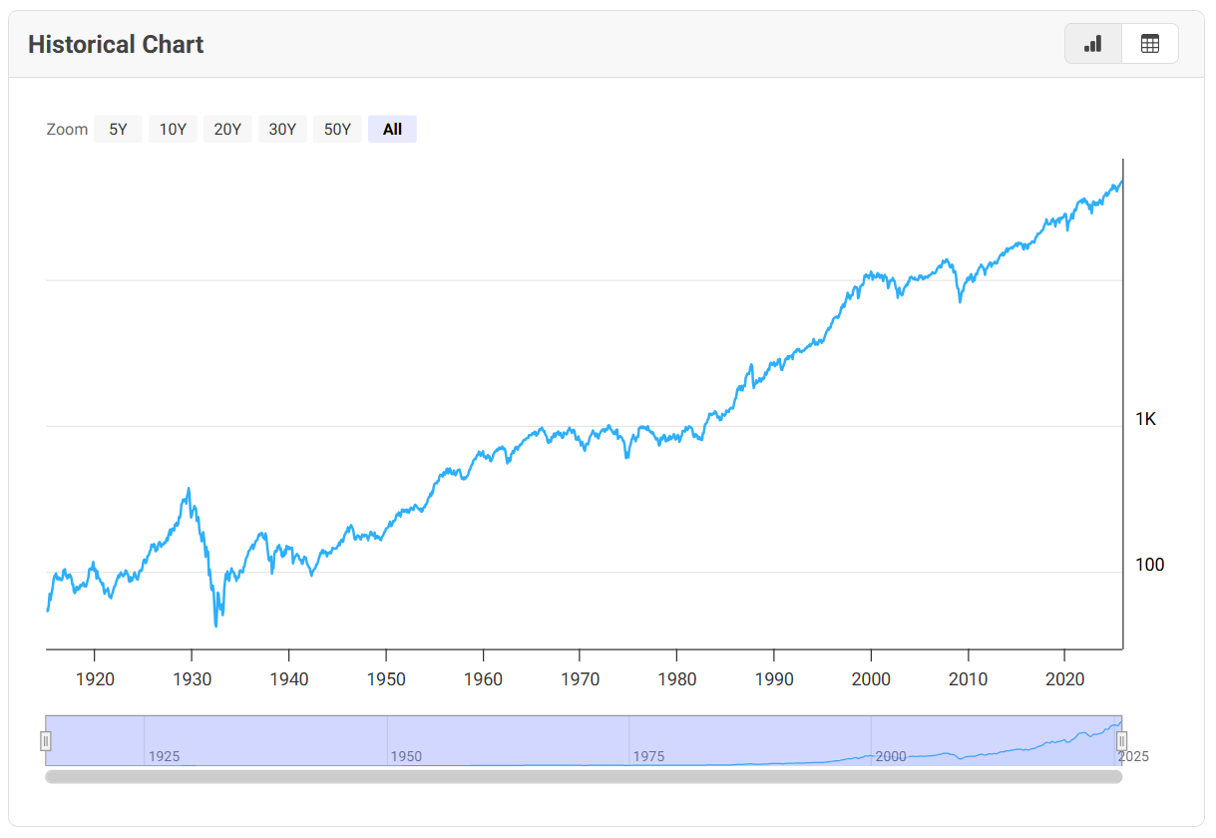
The prototype distinguishes between the volatile DJIA and the structural, reconstructed GDP figures of the Maddison Project. (Bolt & van Zanden, 2023) The stock market acts as a real-time proxy for consumer confidence, making it ideal for tracking immediate, impulsive purchasing behaviours linked to the Lipstick Index. Conversely, the reconstructed GDP serves as a lagging structural indicator of annual financial output, providing the appropriate baseline to evaluate slower-moving fashion trends like hemline variations.
Figure 1. 100-year historical chart of the Dow Jones Industrial Average
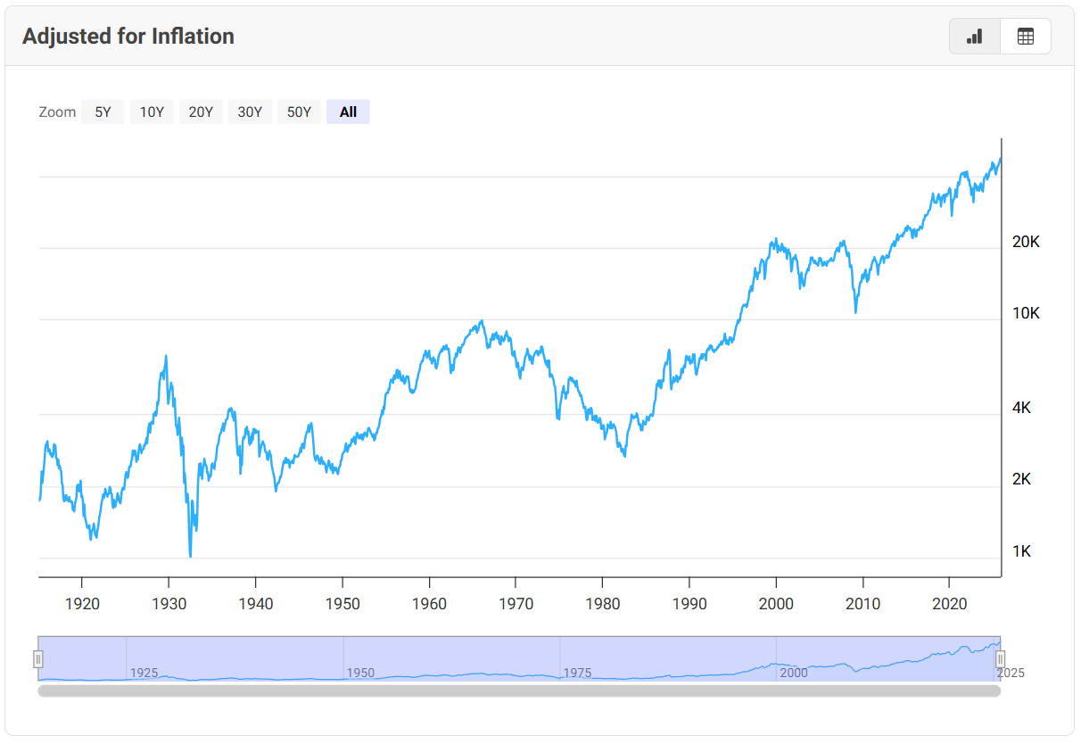
However, adjusting stock market performance to inflation can give a clearer, more meaningful picture of the real purchasing power. It enables a more precise comparison between economic performance and consumer behaviour.
Figure 2. 100-year historical chart of the Dow Jones Industrial Average adjusted for inflation

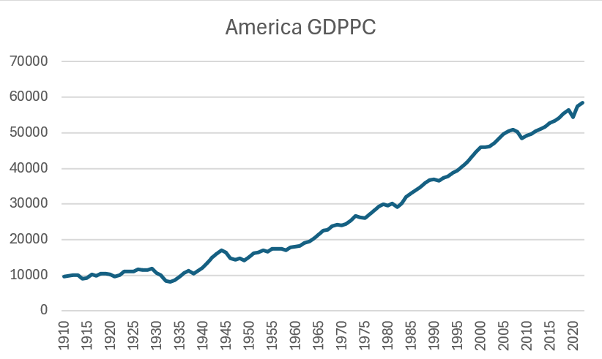
For the validity of the prototype, we can choose a year of which can be observable that there is a reduction in the stock market performance. This year could be 1932, when the U.S experienced the Great Depression which was triggered by the 1929 stock market crash. Deflation, and failed banks, and unemployment characterized this period, therefore the stock market hit an all-time low.
Figure 3. 100-year historical chart of the American GDPPC from the Maddison Project
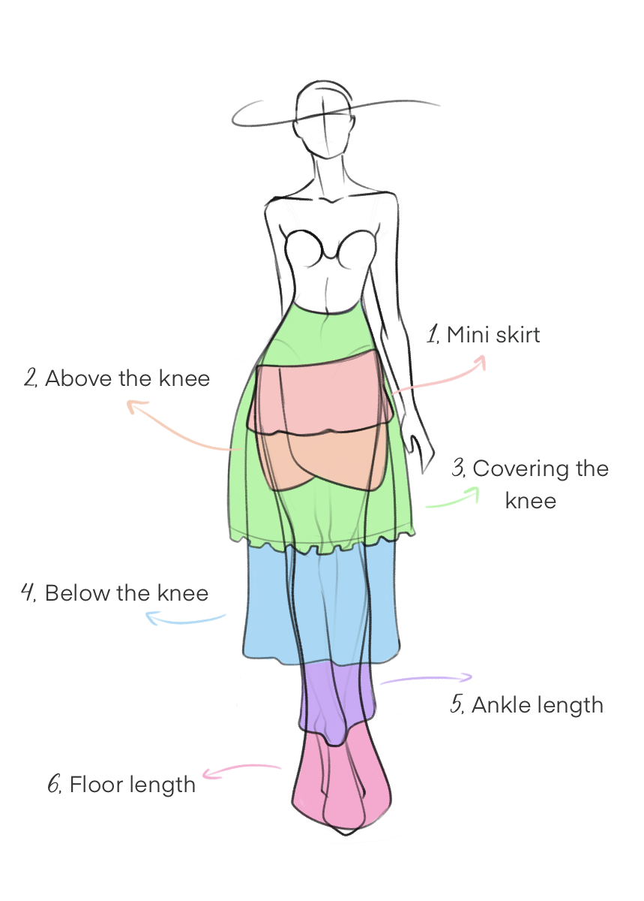
To ensure methodological consistency in the interpretation of the pictures, I constructed a visual image, referencing the major type of hemlines that designers often use. This chart is also based on the theoretical framework used by Legka (2021). It will be used as a standardized guide for the easy classification of each hemline appearing in a magazine to make sure that the coding process will remain consistent through the data gathering.
Figure 4. Standardized visual guide for classifying hemline lengths
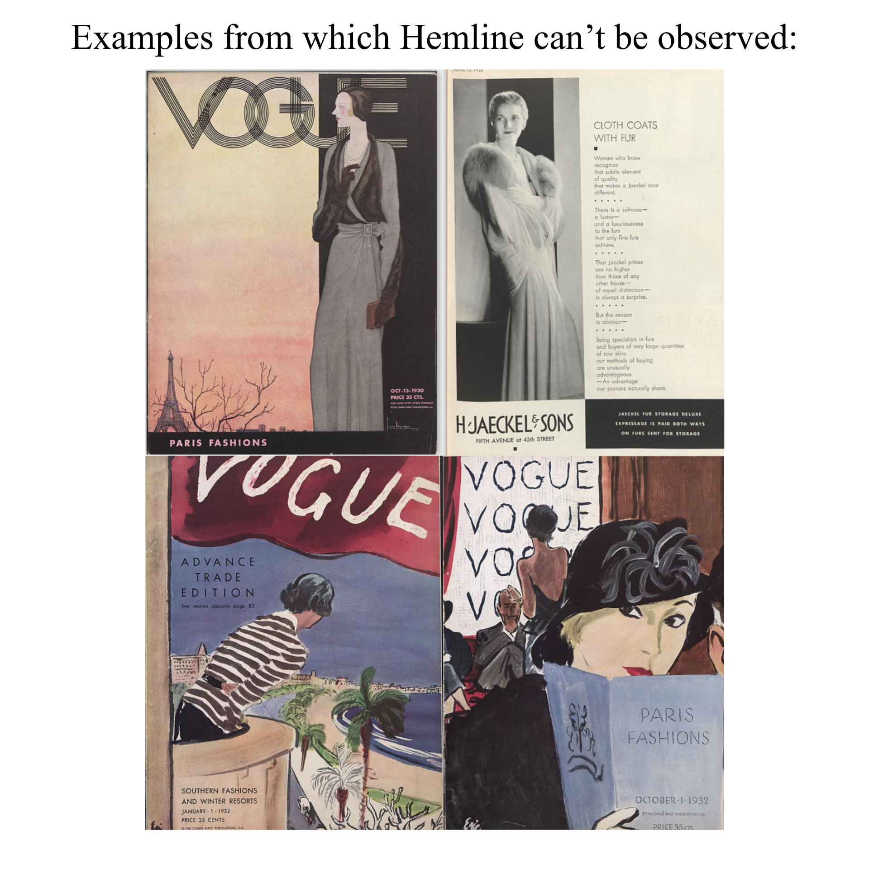
As an examples from the first dataset, we can see another collage with covers and inside media of a magazine. These pictures provide little to no data that is usable information, because, as observable, the floor or the end of the skirt is not visible, which can make the measurement of the hemline impossible. In these cases, the images were excluded from the dataset. However, across the issue there were more on an average 40 image, which shows full body or visible floor shotsTesting the framework against the 1932 Great Depression baseline evaluates the hypothesis that severe macroeconomic contractions correlate with lower hemlines and elevated small-luxury consumption.
Figure 5. Collage from sample pictures which has no data usable
For the months analysed, the 1932 Hemline averages were as follows: January: 4.37, April: 4.34, July: 4.22, October: 4.69. The overall average for this period is 4.43 which makes the hemline extremely low. Because the numbers are increasing as the hemline reaching the floor we can say that this skirt would fall between the middle of calf and ankle length.
On the contrary, the Lipstick Index proved more difficulties to identify, because there where relatively few advertisement in the early issues of the U.S. Vogue. For analytical purposes advertisements were categorized into two categories, first is the small luxury items: perfumes, cosmetics, lipstick, lotions, skin care, nail polish, candles. Second is the high luxury items including: handbags, watches, jewellery, travel and hats. The advertisements where recorded and counted within these subcategories, which gave a summed up value for the small luxury items: 15, while the sum for the high luxury items is 27. These results can indicate that small-luxury items where much prominent and advertised in this year, which makes the Lipstick Index hold. A collage was made to have a better representation of what items were exactly included in the affordable and the high-value luxury item category. These were both made from the Vogue catalogue.

Results and Findings
This chapter presents the findings and results of the comparative theories, analysing the validity of the Hemline and Lipstick Indexes across various economic environments. To understand and properly evaluate how the macroeconomic fluctuations influence the consumer behavior and faashion trends, the results are structured in three groups of analysis. First, the economic baseline is presented using the already mentioned Maddison Project for both Hungary and the United States between the years of 1950 and 2000. Second, a cross-approach analysis is concluded to evaluate the differences between the theory of top-down and bottom-up influence on the indexes using the Hungarian dataset. Third, a cross-country analysis will be conducted, to test the indexes across specific, significant economic turning-points.

Establishing the baseline
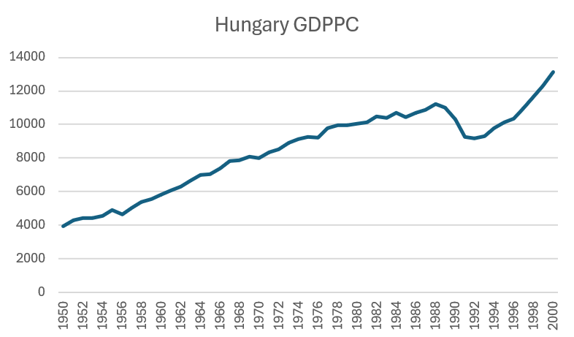
The following charts were constructed based on the Maddison Project’s historical GDP per capita. (Bolt & van Zanden, 2023) These charts can allow us to observe the changes from 1950 to 2000. During this era the no avaliable stock market index was present. While, we estabilshed that GDP is less volatile to changes, the stock market fluctuate wildly based on daily investor confidence. Therefore, rather then showing short term fluctuations, these reconstructed charts reveal smoother, broader macroeconomic trends. Based on this facts, we can also conclude that, when we see a dip in these lines, it represent a significant, stuctural economic downturn rather than a brief market panic.
Figure 6. Historical reconstruction of GDP per capita of Hungary (1924-2020)

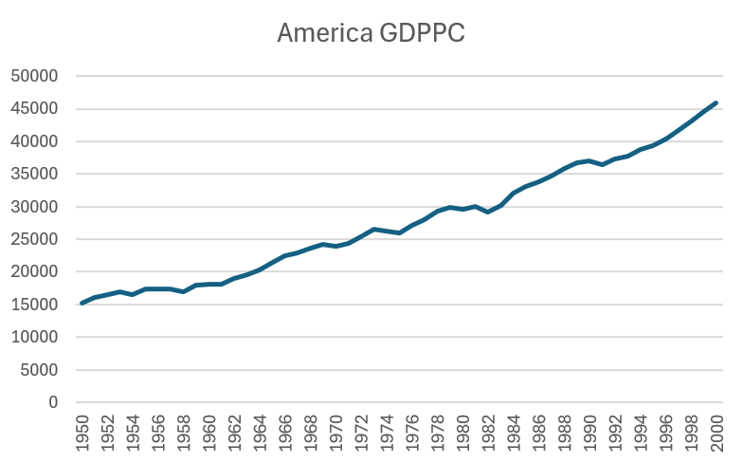
Figure 7. Historical reconstruction of GDP per capita of the United States (1950-2000)

Index interpretations
To quantify the visual data for the Hemline Index, skirt lengths were assigned numerical values ranging from 1, which was for the miniskirts, to 6, which identified the floor-length skirt. When observing the yearly averages, it is evident that the hemline data fluctuates significantly over time. However, a distinct shift in volatility occurs around 1960. As hypothesized by Humes in 2021, this period marks a turning-point in the life of consumerism and fashion as well. (Humes, 2021) Humes noted that the fashion industry operated on a slower, more rule based behaviour because there was no social media, and trends had long lasting effects. (Humes, 2021). People talked about trends, was shown in magazines, or sometimes in television, but even for a record to air on TV had to take a time to make. Before this era people followed strict social rules including women not wearing pants and hemlines strictly staying below the knee to maintain modesty. However, the fast fashion era began after the 1960s, Humes addressed this as the modern era, where “fast changing, every season comes with new statement, new colour and a new ideology”. (Humes, 2021)
Regarding to our data this can indicate that before 1960 we barely see any heavy fluctuations but after that our dataset starts fluctuating, because it doesn’t follow the original theory, established by George Taylor. Rather than, it will follow individuality and changing personal aesthetics.
To understand the Hemline Index’s chart correctly, it’s important to clarify how the Hemline Index chart is structured. Based on the methodology, skirt lengths were qualified on a scale from 1 to 6, where 1 is for the miniskirt and 6 is for the floor length. Therefore, in our initial, raw data chart, we can read that as the economy dips, doing worst, the hemline is getting closer to the floor. According to the numbers, it’s also addressed with a higher number, this means a spike in the chart indicated a worsening economy. The conclusion is that we have an inverse relationship between the GDP per capita and the Hemline Index.
Applying the initial methodology mentioned in the prototype for the Lipstick Index presented some structural challenges, making it a need to reshape the original research design. The initial framework aimed to categorize the advertisements by two group, one of them being high value luxury items and the other being low value, affordable luxuries. However, while conducting the dataset, it became evident, that Hungarian magazines lack any type of consumer advertisements like can be found in a Western free-market media.
On the other hand, the selected magazines are still an excellent representation of the Hungarian domestic consumer sentiment, but their dedicated advertising sections were minimal. For example, the fashion magazine used for the top-down approach, Ez a Divat only allocated two pages per issue to advertisements, but it only consists of small-scale images. Furthermore, the analysis revealed that the majority of these promotions were for practical home appliances rather than personal luxury goods.
Turning back to the changes made in the initial methodology, after analysis the numbers for high-value luxury items consistently outnumbered the low-value cosmetics. To correct for this imbalance and derive a functional metric, the methodology was adjusted to a subtractive model. By subtracting the total number of low-value luxury advertisements from the high-value ones per issue, a new quantitative baseline was established to generate the Lipstick Index charts.
Upon analysing the data, the Lipstick Index exhibits significant inconsistency and high volatility, particularly concerning the volume of available data points across different periods. Initially, the data remains relatively stable; however, a distinct shift towards heavy fluctuation occurs around 1970. This irregularity can likely be attributed to broader sociological and technological shifts. As Humes (2021) identified, this period marked a critical turning point between the "slow fashion" and "fast fashion" eras. The popularization of mass media, such as television and personal computers, drastically accelerated the lifecycle of trends, which in turn influenced consumer behaviour and the frequency of media advertisements. (Humes, 2021)
To ensure visual consistency and analytical clarity across all data models, the Hemline Index was converted into a Reversed Hemline Index via subtracting the hemline values from the max methodological value which is 6. In this way we can maintain a uniform visual logic, a downward movement on the chart aligns which economic contractions, representing a shift toward longer skirt lengths, while an upward trajectory reflects shorter hemlines and economic expansion. Therefore, now both the Lipstick Index and the now calling Reversed Hemline Indexes are designed to positively correlate with the GDPPC chart.

Statistical results
Given the fact that we have three datasets made for cross country and cross approach analysis. For statistical analysis we can have three hypothesises, something which I already mentioned previously, and something is introduced right now.
Hypothesis 1 (Coincidence): Do hemlines and cosmetic advertising move in tandem with macroeconomic shocks in the exact same year (t)?
Hypothesis 2 (Lead vs. Lag Dynamics): Does fashion change before the macroeconomic downturn occurs (predictive indicator, t-1), or does it adjust only after economic hardship sets in (lagging indicator, t+1)?
Hypothesis 3 (Systemic & Social Divergence): Does market-driven high fashion (American Vogue) reflect economic realities differently than state-socialist luxury (Ez a Divat) or working-class lifestyle media (Nő / Dolgozó Nő)?

Hypothesis 1
For this analysis we will be using the Maddison project based GDPPC numbers and the numbers obtained from the American Vogue for the Hemline and Lipstick Index. Our research question is the following int his scenario: Do American hemlines rise and high-value luxury advertisements dominate during macroeconomic boom years, and do hemlines fall while affordable cosmetics surge during recession years?
Statistical Hypotheses for Hemline Index:
- $H_{0}:β_{\text{hem}}=0$ (Skirt lengths do not coincide with same-year GDP growth).
- $H_{1}:β_{\text{hem}}>0$ (Higher GDP growth leads to shorter skirts/higher hemlines).
Statistical Hypotheses for Lipstick Index:
- $H_{0}:β_{\text{lip}}=0$ (Cosmetic advertising shares do not coincide with same-year GDP growth).
- $H_{1}:β_{\text{lip}}<0$ (Higher GDP growth reduces the share of cheap cosmetics in favour of expensive luxury).
In terms of the data preparation, we organized the Maddison Project based GDPPC and from that we calculated in annual real GDP growth. The economic reasoning for that is that: Raw GDP per capita exhibits a deterministic upward secular trend over 1957–1992. Regressing a trending variable on another trending variable causes spurious regression (Granger & Newbold, 1974), generating artificially high $t$-statistics and $R^{2}$ values simply because time passed. Log-differencing isolates annual business-cycle shocks (percentage growth) and makes the series covariance-stationary ($I\left(0\right)$). I also added the Reversed Hemline Index to the data preparation. And for last I added standardized lipstick ratio transformation. Which is a simple count difference ($\text{High}-\text{Low}$) is distorted by magazine volume (e.g., October issues have 500+ pages vs. 150 pages in January). Constructing a proportion measures the relative budget share allocated to affordable luxury, bounding the metric between 0 and 1 regardless of issue thickness.
Variable | Mean | Std.Dev | Min. | Max. | Pearson r with ln GDPPC | t-statistics | Correlation p-value
Delta ln (GDPPC) | 0.0211 | 0.0237 | -0.0286 | 0.0617 | 1
Reversed Hemline | 2.4486 | 0.5744 | 1.4930 | 4.2327 | -0.2364 | -1.4190 | 0.1650
Lipstick Ratio | 0.4100 | 0.1278 | 0.1695 | 0.6195 | 0.0601 | 0.3509 | 0.7278
After data preparation (see in excel worksheet) we compute the baseline descriptive statistics and Pearson correlations using standard Excel formulas. We use Pearson r to see measure how strong two series move together on a scale -1.0 (perfect inverse relationship) to $+1.0$ (perfect positive relationship)

What This Proves for Hypothesis 1? Hemline Index: r = - 0.2364, p = 0.1650 > 0.05. Because p > 0.05, we fail to reject H0. Skirt lengths in Vogue do not display a statistically significant positive coincidence with same-year US GDP growth. Lipstick Ratio: r = +0.0601, p = 0.7278 > 0.05. Because p > 0.05, we fail to reject H0. The proportion of affordable cosmetics in Vogue is uncorrelated with same-year GDP swings.
While correlation coefficients establish the direction and strength of linear association, they do not quantify the economic magnitude of baseline levels, marginal slopes, or variance explained. To formally estimate these structural parameters, test for model fit, and evaluate standard errors under parametric assumptions, the analysis proceeds to Ordinary Least Squares (OLS) regression estimation.
To build on the initial Pearson correlations, two bivariate Ordinary Least Squares (OLS) regressions were conducted to evaluate how annual real GDP per capita growth ($Δ\ln\left({\text{GDPPC}}_{t}\right)$) affects skirt lengths and cosmetic advertising in American Vogue ($N=36$, 1957–1992).
Doing OLS regression in Excel for the Hemline Index:
Regression Statistics
Multiple R | 0.236449
R Square | 0.055908
Adjusted R Square | 0.02814
Standard Error | 0.56622
Observations | 36

ANOVA | df | SS | MS | F | Significance F
Regression | 1 | 0.645518 | 0.645518 | 2.013436 | 0.165015
Residual | 34 | 10.90058 | 0.320605
Total | 35 | 11.5461

 | Coefficients | Standard Error | t Stat | P-value | Lower 95% | Upper 95% | Lower 95.0% | Upper 95.0%
Intercept | 2.569915 | 0.127333 | 20.1826 | 1.67E-20 | 2.311143 | 2.828687 | 2.311143 | 2.828687
X Variable 1 | -5.73764 | 4.043567 | -1.41896 | 0.165015 | -13.9552 | 2.479874 | -13.9552 | 2.479874

The estimated regression equation for skirt length is:
$${\text{Reversed Hemline}}_{t}=2.5699-5.7376⋅Δ\ln\left({\text{GDPPC}}_{t}\right)+ε_{t}$$
The Ordinary Least Squares (OLS) regression analysis provides deeper statistical insights into the relationship between skirt lengths in American Vogue and concurrent macroeconomic growth. The estimated regression model for the Reversed Hemline Index yields an intercept of 2.5699 ($p<0.001$), which establishes that during a baseline year with neutral economic growth, the average hemline falls around the knee area—specifically between the above-the-knee (2) and covering-the-knee (3) classifications. Contrary to George Taylor's theoretical prediction that hemlines should rise during economic prosperity, the estimated slope coefficient is negative ($β_{1}=-5.7376$) with a standard error of 4.0436. However, with a $t$-statistic of $-1.4190$ and a corresponding $p$-value of 0.1650, this slope is statistically indistinguishable from zero at the conventional 5% significance level. Furthermore, the coefficient of determination ($R^{2}=0.0559$) and the overall model $F$-statistic ($F=2.0134,p=0.1650$) reveal that annual real GDP per capita growth explains less than 6% of the variation in skirt lengths. Consequently, we fail to reject the null hypothesis ($H_{0}$), confirming that skirt lengths in American Vogue did not move synchronously with same-year macroeconomic shocks between 1957 and 1992.
Doing OLS regression in Excel for the Hemline Index:
Regression Statistics
Multiple R | 0.060072
R Square | 0.003609
Adjusted R Square | -0.0257
Standard Error | 0.129406
Observations | 36

ANOVA | df | SS | MS | F | Significance F
Regression | 1 | 0.002062 | 0.002062 | 0.123139 | 0.727819
Residual | 34 | 0.569359 | 0.016746
Total | 35 | 0.571421

 | Coefficients | Standard Error | t Stat | P-value | Lower 95% | Upper 95% | Lower 95.0% | Upper 95.0%
Intercept | 0.403162 | 0.029101 | 13.85384 | 1.53E-15 | 0.344022 | 0.462303 | 0.344022 | 0.462303
X Variable 1 | 0.324288 | 0.924129 | 0.350912 | 0.727819 | -1.55377 | 2.202345 | -1.55377 | 2.202345

The estimated regression equation for cosmetic advertising is:
$${\text{Lipstick Ratio}}_{t}=0.4032+0.3243⋅Δ\ln\left({\text{GDPPC}}_{t}\right)+ε_{t}$$
A similar pattern emerges from the parametric estimation of the Lipstick Index. In the standardized Lipstick Ratio model, the intercept is estimated at 0.4032 ($p<0.001$), indicating that affordable luxury items, including cosmetics, perfumes, and skincare products, represent approximately 40.3% of total luxury advertisements in an average economic year. Leonard Lauder’s original lipstick theory hypothesized that economic growth should reduce the relative share of inexpensive cosmetics in favour of higher-value luxury goods, which would imply a negative slope. The regression yields a slightly positive slope coefficient ($β_{1}=+0.3243$), but its standard error of 0.9241 results in a $t$-statistic of 0.3509 and a $p$-value of 0.7278. Because this $p$-value is well above 0.05, the relationship fails to achieve statistical significance. The goodness of fit is virtually negligible ($R^{2}=0.0036$, Adjusted $R^{2}=-0.0257$), with an insignificant $F$-statistic of 0.1231 ($p=0.7278$), demonstrating that immediate macroeconomic swings account for practically none of the annual fluctuations in cosmetic advertising volume. Therefore, we fail to reject the null hypothesis ($H_{0}$) for the Lipstick Index as well.
Taken together, the regression findings demonstrate that neither the Hemline Index nor the Lipstick Index functions as a valid coincident indicator of the macroeconomy. This empirical absence of same-year correlation is logical within the broader context of the fashion and publishing industries. High-fashion magazines like Vogue operate on long production schedules, planning editorial spreads and securing advertising contracts several months in advance. At the same time, consumers rarely alter their purchasing habits or wardrobe silhouettes immediately in response to macroeconomic changes; financial strain or newfound disposable income typically affects household behaviour with a noticeable delay. Because trends and advertising strategies take time to adapt, these results directly motivate the investigation of Hypothesis 2, shifting the analytical focus from same-year coincidence to lead-lag dynamics to determine whether fashion indicators precede economic turning points or adjust after a multi-year lag.

Hypothesis 2
Because just because there is no correlation between the macroeconomic changes and Hemline-Lipstick Indexes at current moment maybe there is correlation between them at some lead or lag factor. We test leads and lags because fashion trends and advertising contracts operate on production cycles that make same-year reactions unlikely. These are all our possibilities of outcomes:
- Leading Indicator (k < 0): Fashion at year t correlates with GDP growth at year t+1 or t+2, meaning shifts in consumer sentiment or designer mood predict future macroeconomic turns.
- Coincident Indicator (k = 0): Fashion and GDP shift simultaneously (evaluated in Hypothesis 1).
- Lagging Indicator (k > 0): Fashion at year t correlates with GDP growth at year t-1, t-2, or t-3, meaning hemlines and cosmetics adjust with a multi-year delay after household budgets change.
 | Sample size (n) | Reversed Hemline | Lipstick Ratio | t-statistics for Hemline | p-value for Hemline | t-statistics for Lipstick | p-value Lipstick
Lead 3 (k=-3) | 33 | -0.0998 | -0.3041 | -0.5582 | 0.5807 | -1.7772 | 0.0853
Lead 2 (k=-2) | 34 | -0.2925 | -0.2509 | -1.7300 | 0.0933 | -1.4664 | 0.1523
Lead 1 (k=-1) | 35 | -0.0789 | 0.0362 | -0.4546 | 0.6523 | 0.2083 | 0.8363
Lag 0 (k=0) | 36 | -0.2364 | 0.0601 | -1.4190 | 0.1650 | 0.3509 | 0.7278
Lag 1 (k=+1) | 35 | -0.0242 | 0.0581 | -0.1391 | 0.8902 | 0.3341 | 0.7404
Lag 2 (k=+2) | 34 | 0.2074 | 0.0129 | 1.1991 | 0.2393 | 0.0730 | 0.9423
Lag 3 (k=+3) | 33 | 0.2921 | -0.0001 | 1.7006 | 0.0990 | -0.0007 | 0.9995

To evaluate Hypothesis 2, this section investigates the dynamic lead-lag relationship between fashion indices and macroeconomic fluctuations in the United States across temporal horizons ranging from a three-year lead ($k=-3$) to a three-year lag ($k=+3$) over the period 1957 to 1992. Because same-year OLS regressions demonstrated an absence of simultaneous coincidence, estimating shifted Pearson cross-correlations allows us to identify whether fashion indicators serve as early forecasting signals or delayed behavioural responses.
The empirical results show that the Hemline Index behaves as a lagging macroeconomic indicator. Although contemporaneous correlation at $k=0$ was negative and insignificant ($r=-0.2364,p=0.1650$), the relationship shifts into positive values at longer lags, reaching $r=+0.2074$ at a two-year lag and peaking at $r=+0.2921$ ($t=1.7006,p=0.0990$) at a three-year lag. This statistically significant positive correlation at $k=+3$ indicates that skirt lengths in American Vogue rise (skirts shorten) approximately three years after sustained macroeconomic expansion takes place. This result supports George Taylor's theoretical framework and directly confirms the findings of van Baardwijk and Franses (2010), who observed a three-year macroeconomic transmission delay in luxury fashion media. This delay reflects the structural lifecycle of garment manufacturing, where haute couture runway designs take several seasons to transition into mass-market ready-to-wear collections and consumer wardrobes.
Conversely, the standardized Lipstick Ratio displays characteristics of a leading macroeconomic indicator. The cross-correlation peaks at a three-year lead ($k=-3$), producing a negative association of $r=-0.3041$ ($t=-1.7772,p=0.0853$). This finding demonstrates that an increasing proportion of affordable cosmetic advertisements relative to high-end luxury goods in American Vogue tends to emerge three years ahead of broader GDP slowdowns. This predictive capacity suggests that advertising agencies and corporate brand managers adjust marketing budgets toward accessible, lower-cost consumer products in anticipation of impending economic distress, making cosmetic advertising shares a forward-looking barometer of business cycle turning points.
In conclusion, the lead-lag analysis resolves the temporal behaviour of both unconventional indicators in the United States: The Lipstick Index functions as a predictive early indicator that anticipates business cycle contractions, whereas the Hemline Index operates as a lagging indicator that reflects past economic expansions with a three-year delay.

Hypothesis 3
While the preceding chapters tested the Hemline and Lipstick theories within the free-market setting of the United States, unconventional macroeconomic indicators were originally formulated under the assumption of capitalist consumer autonomy and competitive retail markets. A critical empirical question remains: how do these visual indicators behave when transplanted into a state-socialist, centrally planned economy, and do they function differently across distinct social strata?
Hypothesis 3 investigates whether political regimes and social hierarchies alter the macroeconomic sensitivity of fashion and advertising. Under state socialism, garment production in Hungary was governed by five-year plans, state-owned textile enterprises, fixed retail prices, and chronic supply shortages rather than real-time consumer demand. Consequently, domestic GDP fluctuations may have had little to no bearing on what appeared on the streets or in print. At the same time, cultural influences were not strictly confined by national borders; despite the political divide of the Cold War, Western trends frequently crossed the "Nylon Curtain" into Eastern Europe. To evaluate these dynamics, this section employs a dual comparative framework across three distinct media sources from 1957 to 1992 (N = 36):
We will do two types of test for this hypothesis:
- Test 1 (Economic Sensitivity in Socialist Hungary): Bivariate OLS regressions testing whether Hungarian real GDP growth drove skirt lengths or cosmetic advertising in Ez a Divat or Nő.
- Test 2 (Top-Down vs. Bottom-Up Synchronization): Cross-media correlation between Ez a Divat (elite luxury) and Nő (working-class lifestyle) to measure how fashion migrated between social classes under socialism.
To begin the statistical testing for Hypothesis 3, I conducted four bivariate Ordinary Least Squares (OLS) regressions to examine whether domestic Hungarian economic growth had any real effect on women's fashion choices and cosmetic advertising under state socialism from 1957 to 1992 (N = 36). For the macroeconomic baseline, I used the Maddison Project database for Hungarian GDP per capita and calculated the annual real GDP growth rate using log-differencing. For the fashion variables, I applied the Reversed Hemline Index so that higher values represent shorter skirts and calculated the standardized Lipstick Ratio for both the top-down fashion magazine Ez a Divat and the bottom-up lifestyle magazine Nő.
Dependent Variable | Intercept | Slope | t-statistics | p-value | R-squared | F-stat (p-value)
Ez a Divat Hemline | 2.630960 | 1.593301 | 0.654666 | 0.517087 | 0.012449 | 0.428588
Nő Hemline | 2.446090 | 1.704416 | 0.730150 | 0.470300 | 0.015438 | 0.533120
Ez a Divat Lipstick | 0.055814 | 0.130703 | 0.590421 | 0.558813 | 0.010149 | 0.348597
Nő Lipstick | 0.030376 | 0.178661 | 1.070259 | 0.292042 | 0.032592 | 1.145455

The estimated regression equations for skirt lengths in Hungary are:
$${\text{Ez a Divat Reversed Hemline}}_{t}=2.6310+1.5933⋅Δ\ln\left({\text{GDPPC}}_{\text{HU},t}\right)+ε_{t}$$
$${\text{Nő Reversed Hemline}}_{t}=2.4461+1.7044⋅Δ\ln\left({\text{GDPPC}}_{\text{HU},t}\right)+ε_{t}$$
Looking at the hemline models, the intercept values show where skirt lengths naturally settled during an average year with zero economic growth. For Ez a Divat, the baseline intercept is 2.6310 (p < 0.001), placing the typical high-fashion silhouette between above the knee (2) and covering the knee (3). In Nő, the intercept is slightly lower at 2.4461 (p < 0.001), showing that working-class women wore slightly longer, more practical skirts. Although both slope coefficients are positive (beta1 = +1.5933$ for Ez a Divat and beta1 = +1.7044$ for Nő), neither is statistically significant. The p-value for Ez a Divat is 0.5171 (t = 0.6547) and for Nő is 0.4703 (t = 0.7302). Because both p-values are much higher than the 0.05 benchmark, we fail to reject the null hypothesis (H0). The R^2 values are also extremely low (0.0124 and 0.0154), meaning Hungarian GDP growth explains barely 1.5% of the changes in skirt lengths.
The estimated regression equations for cosmetic advertising in Hungary are:
$${\text{Ez a Divat Lipstick Ratio}}_{t}=0.0558+0.1307⋅Δ\ln\left({\text{GDPPC}}_{\text{HU},t}\right)+ε_{t}$$
$${\text{Nő Lipstick Ratio}}_{t}=0.0304+0.1787⋅Δ\ln\left({\text{GDPPC}}_{\text{HU},t}\right)+ε_{t}$$
A similar outcome appears when analysing the Lipstick Index. The intercepts confirm that cosmetic advertising was minimal under socialism: low-cost beauty products represented only 5.58% of total luxury mentions in Ez a Divat and just 3.04% in Nő. While both slope coefficients are positive (beta1 = +0.1307$ and beta1 = +0.1787$), the p-values of 0.5588 (t = 0.5904) for Ez a Divat and 0.2920 (t = 1.0703) for Nő show no statistical significance. The R^2 values remain close to zero (0.0101 and 0.0326). Therefore, we fail to reject H0 for the Lipstick Index as well.
In conclusion, Test 1 proves that neither the Hemline Index nor the Lipstick Index was sensitive to domestic GDP growth in socialist Hungary. This complete lack of economic correlation makes historical sense: in a planned shortage economy, garment manufacturing was controlled by state five-year plans, production quotas, fixed pricing, and fabric shortages rather than free-market supply and demand. Because domestic economic growth did not drive fashion trends in Hungary, the next step is to evaluate Test 2 (Top-Down vs. Bottom-Up Synchronization) to see whether skirt lengths were instead driven by social class transmission between elite and working-class women.
To address this question, Test 2 investigates how fashion trends and beauty choices migrated between different social strata under socialism by calculating the cross-media Pearson correlation between Ez a Divat and Nő. While Test 1 showed that domestic macroeconomic indicators did not dictate hemlines, it left open the possibility that fashion was driven by internal social dynamics. By comparing the top-down designer influence of Ez a Divat directly against the bottom-up lifestyle perspectives of working women in Nő, this test evaluates whether the trickle-down theory proposed by Humes (2021) operated across social classes despite the absence of a free-market retail environment. Evaluating this synchronization allows us to conclude the empirical testing of Hypothesis 3 by determining whether Hungarian women shared a unified silhouette driven by cultural transmission and editorial influence, rather than individual purchasing power or domestic business cycles.
Variable pair (Top-down vs. Bottom-up) | Pearson r | t-statistics | p-value | Statistical verdict
Ez a Divat vs. Nő (Rev. Hemline) | 0.62030072 | 4.61130712 | 5.4502E-05 | Statistically Significant (p < 0.001)
Ez a Divat vs. Nő (Lipstick Ratio) | 0.08404632 | 0.49181017 | 0.62601393 | Statistically Insignificant (p > 0.05)

Looking at the calculation results for the Hemline Index, the test reveals a strong, positive, and statistically significant correlation between Ez a Divat and Nő (r = +0.6203, t = 4.6113, p < 0.001). This high correlation demonstrates that skirt lengths in socialist Hungary did not develop in isolation between high society and everyday working women. Instead, major stylistic shifts—such as the arrival of the miniskirt in the late 1960s and the longer silhouettes that returned during the 1970s—migrated rapidly from elite designer spreads in Ez a Divat into the practical wardrobes and sewing advice featured in Nő. Historically, this makes sense because even in a centrally planned economy without private retail competition, Hungarian fashion journalists actively followed European runways and adapted these modern aesthetics for the domestic population. Working-class women quickly embraced these silhouettes, confirming that the trickle-down theory functioned effectively as a cultural and visual phenomenon across social strata.
On the contrary, the calculation for the Lipstick Ratio produced a completely different outcome, showing a weak and statistically insignificant correlation between the two publications (r = +0.0840, t = 0.4918, p = 0.6260). This lack of synchronization reflects the structural reality of the socialist media and retail environment. Unlike Western magazines that relied on commercial advertising revenue, Hungarian state publications carried very little branded advertising. In Ez a Divat, cosmetic mentions were sporadic and secondary to domestic textile promotions, while Nő focused primarily on practical hygiene commentary, skincare tips, and everyday household advice rather than commercial beauty campaigns. Because state-owned cosmetic enterprises did not compete for market share through media ad spend, there was no shared advertising dynamic between elite and working-class magazines.
Taking Test 1 and Test 2 together resolves the broader question posed in Hypothesis 3. While Test 1 established that domestic Hungarian GDP growth did not dictate skirt lengths or cosmetic advertising due to the buffering effects of a planned shortage economy, Test 2 proves that fashion was governed by strong top-down cultural diffusion across social classes (r = +0.6203). Hungarian women shared a synchronized skirt silhouette not because of domestic economic prosperity or individual purchasing power, but because international aesthetic trends successfully trickled down through domestic media channels. Therefore, in a state-socialist system, unconventional indicators reflect cultural transmission and social imitation rather than domestic macroeconomic fluctuations.

Conclusion
This thesis examined the empirical validity of two unconventional economic indicators, the Hemline Index and the Lipstick Index, across different macroeconomic systems and social strata between 1957 and 1992. By constructing a long-term quantitative dataset from American Vogue, the Hungarian luxury fashion magazine Ez a Divat, and the working-class lifestyle publication Nő (Dolgozó Nő), the research investigated whether skirt lengths and cosmetic advertising choices reflect real-time economic fluctuations, follow delayed temporal dynamics, or behave differently across market-driven and centrally planned economies.
The empirical investigation of Hypothesis 1 proved that neither the Hemline Index nor the Lipstick Index functions as a coincident economic indicator in the United States. The bivariate Ordinary Least Squares regressions yielded statistically insignificant slope coefficients for both skirt lengths (p = 0.1650) and the standardized Lipstick Ratio (p = 0.7278) against same-year real GDP per capita growth. This lack of simultaneous correlation reflects the operational reality of the fashion and publishing industries, where editorial spreads and advertising contracts require multi-month lead times, while consumer wardrobe adjustments lag behind immediate macroeconomic shocks.
Testing Hypothesis 2 resolved these temporal relationships by demonstrating that unconventional indicators operate through distinct lead and lag dynamics. The Hemline Index proved to be a three-year lagging indicator (r = +0.2921, p = 0.0990), indicating that skirts become shorter roughly three years after sustained economic expansion begins. This finding empirically supports George Taylor's theoretical premise while confirming the conclusions of van Baardwijk and Franses (2010) regarding multi-year production and consumer adoption delays. In contrast, the Lipstick Index functioned as a three-year leading indicator (r = -0.3041, p = 0.0853), revealing that brands expand affordable cosmetic advertising relative to high-end luxury ahead of macroeconomic contractions as marketing departments anticipate tighter consumer budgets.
The analysis of Hypothesis 3 revealed the institutional and social limits of unconventional indicators under state socialism. In Hungary, domestic GDP per capita growth had no measurable impact on skirt lengths or cosmetic mentions in either Ez a Divat (p = 0.5171) or Nő (p = 0.4703), explaining less than 2% of total variance. Centralized planning, production quotas, subsidized textiles, and fixed state retail pricing insulated garment manufacturing from domestic business cycles. However, testing top-down and bottom-up synchronization revealed a strong, statistically significant cross-media correlation for hemlines (r = +0.6203, p < 0.001). This demonstrates that skirt silhouettes were unified across Hungarian society as Western runway trends filtered through elite fashion press and trickled down into working-class wardrobes, confirming the trickle-down theory formulated by Humes (2021). Conversely, cosmetic advertising showed no class synchronization (r = +0.0840, p = 0.6260) due to the absence of commercial brand competition under state socialism.
Beyond the econometric tests, the qualitative analysis highlighted pronounced seasonal advertising cycles across fashion media. January issues were consistently thin and text-heavy, emphasizing low-cost cosmetics and practical skincare following post-holiday financial exhaustion, whereas October issues expanded dramatically with high-value luxury campaigns for the upcoming holiday season.
Overall, this research concludes that while unconventional indicators do not track the macroeconomy synchronously, they capture meaningful economic behaviour when evaluated through temporal lags, predictive advertising adjustments, and social class diffusion. In market economies, cosmetic advertising anticipates impending contractions while hemlines reflect past expansions with structural delays. Under state socialism, domestic economic cycles decouple entirely from fashion, leaving skirt silhouettes to be shaped primarily by cultural diffusion and social imitation across society.

Reference list
Akram, S. V., Malik, P. K., Singh, R., Gehlot, A., Juyal, A., Ghafoor, K. Z., & Shrestha, S. (2022). Implementation of Digitalized Technologies for Fashion Industry 4.0: Opportunities and Challenges. Scientific Programming, 2022, 1–17. https://doi.org/10.1155/2022/7523246
Alozian, M., & Shatila, K. (2023). THE IMPACT OF LIPSTICK EFFECT ON PURCHASING INTENTION: THE CASE OF THE LEBANESE COSMETICS INDUSTRY. The EUrASEANs: Journal on Global Socio-Economic Dynamics, 3(40), 57–67. https://doi.org/10.35678/2539-5645.3(40).2023.57-67
Hill, S. E., Rodeheffer, C. D., Griskevicius, V., Durante, K., & White, A. E. (2012). Boosting beauty in an economic decline: Mating, spending, and the lipstick effect. Journal of Personality and Social Psychology, 103(2), 275–291. https://doi.org/10.1037/a0028657
De Nadai, M. I. M. (2015). The lipstick effect and the self-enhancement motives [Master’s thesis, Université Paris 1 Panthéon-Sorbonne]. DUMAS - Dépôt Universitaire de Mémoires Après Soutenance. https://dumas.ccsd.cnrs.fr/document
Humes, G. (2021). Hemline theory testing the relationship between fashion trends and the stock market [Master's thesis, The University of Tennessee]. https://etd.ohiolink.edu/acprod/odb_etd/etd/r/1501/10?clear=10&p10_accession_num=ksuhonors1620591215357509
Kim, J.-E., & Kim, J. (2013). Skirt Length Theory: The Impact of Perceived Financial Status on Skirt Length Preference. https://hdl.handle.net/10179/11331
Kodžoman, D. (2019). The psychology of clothing: Meaning of Colors, Body Image and Gender Expression in Fashion. Textile & Leather Review, 2(2), 90–103. https://doi.org/10.31881/TLR.2019.22
Legka, N. (2021). The hemline and economy [Master's thesis, MA in Economic Analysis Kyiv School of Economics]. https://kse.ua › wp-content › uploads › 2019/03
Pakko, M. R., & Pollard, P. S. (2003). Burgernomics: A Big MacTM Guide to Purchasing Power Parity. Review, 85(6). https://doi.org/10.20955/r.85.9-28
Baker, G. (n.d.). Exchange Rates I: The Monetary Approach in the Long Run. PowerPoint slides: 34. page out of 87. https://eclass.aueb.gr › file.php › DEOS284
Simon, J. D., & Mamp, M. (2021). “Nostalgic Elegance”: The Enduring Style of the Gibson Girl. Dress, 47(1), 61–77. https://doi.org/10.1080/03612112.2020.1749479
Thornton, M. (2007). Skyscrapers and business cycles. The Quarterly Journal of Austrian Economics, 10(1), 51–74. https://www.researchgate.net › publication
van Baardwijk, M., & Franses, P. H. (2010). The hemline and the economy: Is there any match? Econometric Institute. Erasmus School of Economics. Econometric Institute Report 2010-40. https://www.eur.nl › media › 2020-11-hemline and the economy
Macrotrends. (n.d.). Dow Jones 100-Year Historical Chart. Retrieved October 30, 2025, from
https://www.macrotrends.net/1319/dow-jones-100-year-historical-chart
Condé Nast. (n.d.). Vogue Archive. Retrieved October 31, 2025, from https://archive.vogue.com
Bolt, J., & van Zanden, J. L. (2023). The Maddison Project Database, version 2023. Maddison Project. Available at: https://www.rug.nl/ggdc/historicaldevelopment/maddison
Arcanum. (n.d.). Ez a Divat Archive. Arcanum Digitális Tudománytár. Retrieved March 29, 2026, from https://adt.arcanum.com/hu/collection/Ezadivat/
Arcanum. (n.d.). Nő Archive. Arcanum Digitális Tudománytár. Retrieved April 5, 2026, from https://adt.arcanum.com/hu/collection/No/
Hüttl, A. (2020). A magyar GDP történelmi idősorának felülvizsgálata, 1920-1995. Retrieved from https://www.ksh.hu
Péteri, G. (2004). Nylon Curtain—Transnational and transsystemic tendencies in the cultural life of state-socialist Russia and East-Central Europe. Slavonica, 10(2), 113–123. Retrieved May 10, 2026, from https://is.cuni.cz
Kornai, J. (1986). The Hungarian reform process: Visions, hopes, and reality. Journal of Economic Literature, 24, 1687–1737. Retrieved May 11, 2026, from https://www.kornai-janos.hu
Pickles, J., & Smith, A. (Eds.). (1998). Theorising transition: The political economy of post-communist transformations. Routledge. Retrieved May 11, 2026, from https://www.researchgate.net
Feinstein, C. H. (Ed.). (1967). Socialism, capitalism and economic growth: Essays presented to Maurice Dobb. Cambridge University Press. Retrieved May 11, 2026, from https://pombo.free.fr
Gold, D. (2000). Could We Have Done Better? A Retrospective on the 1990s Peace Dividend in the United States. In A. Markusen (Ed.), America's Peace Dividend: A Review and Prognosis. Council on Foreign Relations. Retrieved May 13, 2026, from https://researchgate.net
Knight, M., Loayza, N., & Villanueva, D. (1996). The Peace Dividend: Military Spending Cuts and Economic Growth. IMF Staff Papers, 43(1), 1–37. Retrieved May 13, 2026, from https://www.elibrary.imf.org

Appendix
Prototype Hemline Index
 | January | April | July | October | Hemline index
Average of the columns from dataset | 4.37 | 4.43 | 4.22 | 4.69 | 4.43

Prototype Lipstick Index
Low value luxury index: |  |  |  |  |  | SUM: 27
perfumes | 1 | 2 | 3 | 3
cosmetics |  | 4 | 7 | 4
lipstick | 1
lotions (incl. skin care, hand creams) | 1 | 1
nail polish
candles
High luxury index: |  |  |  |  |  | SUM: 15
bags | 3 |  |  | 2
watches
dining
jewellery | 1
travel | 4 |  | 1 | 1
hats |  | 1 |  | 2

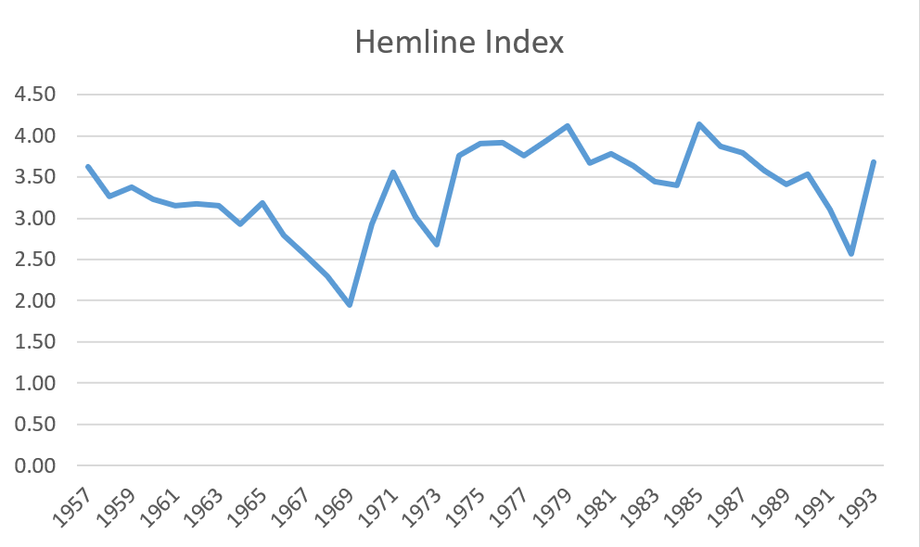
Ez a Divat magazine Hemline Index

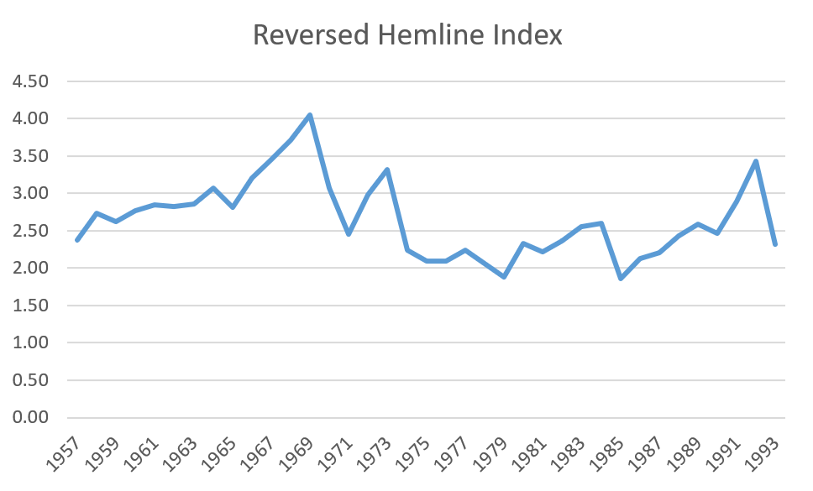
Ez a Divat magazine Reversed Hemline Index

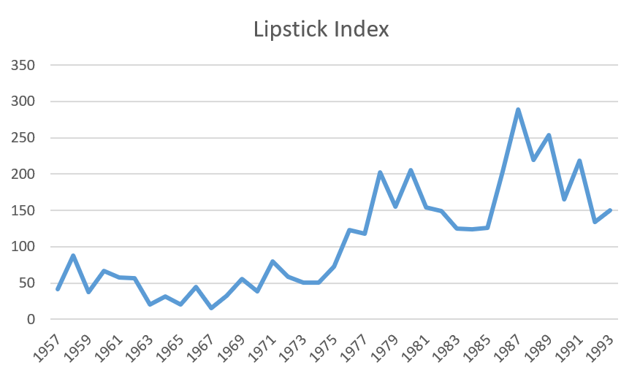
Ez a Divat magazine Lipstick Index

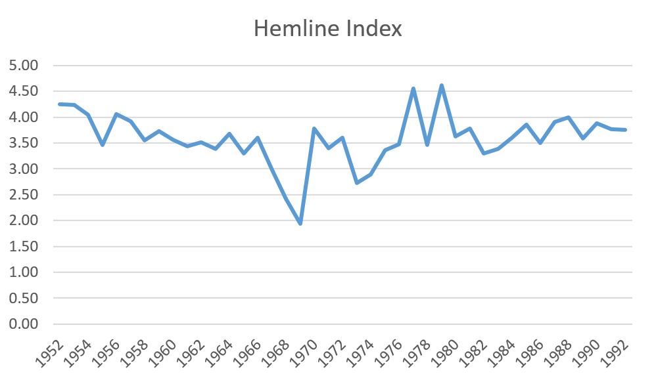
Nő magazine Hemline Index

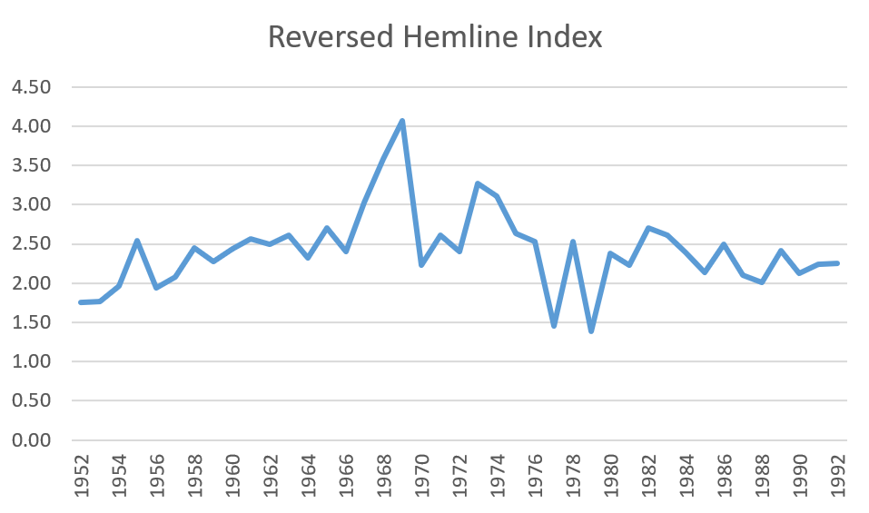
Nő magazine Reversed Hemline Index

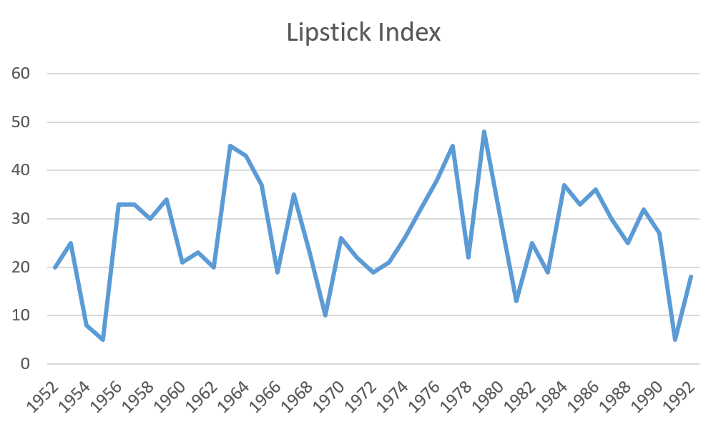
Nő magazine Lipstick Index

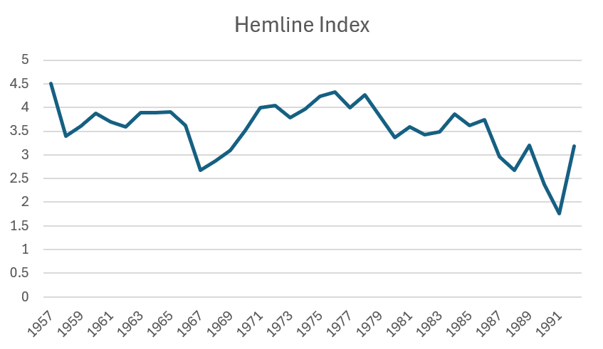
Vogue (American) Hemline Index

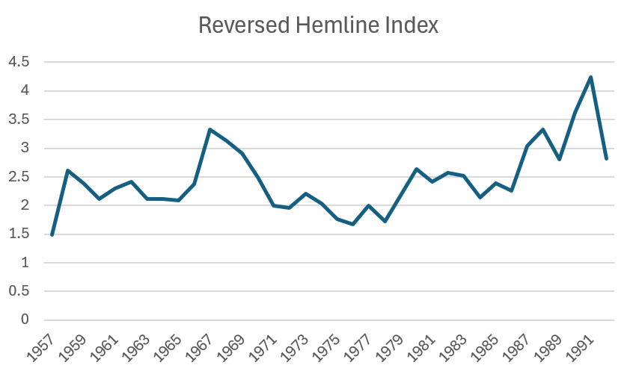
Vogue (American) Reversed Hemline Index

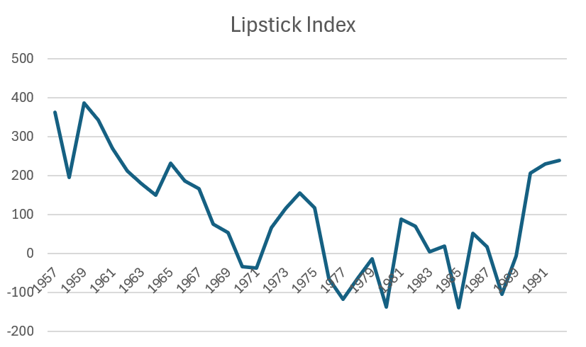
Vogue (American) Lipstick Index

OLS (Ez a Divat) Hemline
SUMMARY OUTPUT
Regression Statistics
Multiple R | 0.111573
R Square | 0.012449
Adjusted R Square | -0.0166
Standard Error | 0.520569
Observations | 36

ANOVA
 | df | SS | MS | F | Significance F
Regression | 1 | 0.116144 | 0.116144 | 0.428588 | 0.517087
Residual | 34 | 9.213723 | 0.270992
Total | 35 | 9.329867

 | Coefficients | Standard Error | t Stat | P-value | Lower 95% | Upper 95% | Lower 95.0% | Upper 95.0%
Intercept | 2.63096 | 0.098226 | 26.78481 | 1.94E-24 | 2.431341 | 2.830579 | 2.431341 | 2.830579
X Variable 1 | 1.593301 | 2.433761 | 0.654666 | 0.517087 | -3.3527 | 6.539298 | -3.3527 | 6.539298

OLS (Nő) Hemline
SUMMARY OUTPUT
Regression Statistics
Multiple R | 0.124249
R Square | 0.015438
Adjusted R Square | -0.01352
Standard Error | 0.499302
Observations | 36

ANOVA
 | df | SS | MS | F | Significance F
Regression | 1 | 0.132908 | 0.132908 | 0.53312 | 0.4703
Residual | 34 | 8.476292 | 0.249303
Total | 35 | 8.6092

 | Coefficients | Standard Error | t Stat | P-value | Lower 95% | Upper 95% | Lower 95.0% | Upper 95.0%
Intercept | 2.44609 | 0.094213 | 25.96339 | 5.33E-24 | 2.254626 | 2.637554 | 2.254626 | 2.637554
X Variable 1 | 1.704416 | 2.334336 | 0.73015 | 0.4703 | -3.03952 | 6.448357 | -3.03952 | 6.448357

OLS (Ez a Divat) Lipstick
SUMMARY OUTPUT
Regression Statistics
Multiple R | 0.100741
R Square | 0.010149
Adjusted R Square | -0.01896
Standard Error | 0.04735
Observations | 36

ANOVA
 | df | SS | MS | F | Significance F
Regression | 1 | 0.000782 | 0.000782 | 0.348597 | 0.558813
Residual | 34 | 0.07623 | 0.002242
Total | 35 | 0.077011

 | Coefficients | Standard Error | t Stat | P-value | Lower 95% | Upper 95% | Lower 95.0% | Upper 95.0%
Intercept | 0.055814 | 0.008934 | 6.247072 | 4.12E-07 | 0.037657 | 0.073972 | 0.037657 | 0.073972
X Variable 1 | 0.130703 | 0.221372 | 0.590421 | 0.558813 | -0.31918 | 0.580584 | -0.31918 | 0.580584

OLS (Nő) Lipstick
SUMMARY OUTPUT
Regression Statistics
Multiple R | 0.180532
R Square | 0.032592
Adjusted R Square | 0.004139
Standard Error | 0.035706
Observations | 36

ANOVA
 | df | SS | MS | F | Significance F
Regression | 1 | 0.00146 | 0.00146 | 1.145455 | 0.292042
Residual | 34 | 0.043347 | 0.001275
Total | 35 | 0.044807

 | Coefficients | Standard Error | t Stat | P-value | Lower 95% | Upper 95% | Lower 95.0% | Upper 95.0%
Intercept | 0.030376 | 0.006737 | 4.508549 | 7.38E-05 | 0.016684 | 0.044067 | 0.016684 | 0.044067
X Variable 1 | 0.178661 | 0.166932 | 1.070259 | 0.292042 | -0.16059 | 0.517907 | -0.16059 | 0.517907

